7/4/2025

Klil Harburger, Rotem Azriel, Idan Schreiber, Yuval Antman

Introduction to data science

[Link to our Git Repository](https://github.com/yuvalantman/covid_crime_research)

Balancing the Curve

Modelling the Impact of Lockdown Policies on Domestic Violence and COVID-19 Outcomes

**1.Introduction**

The COVID-19 pandemic forced governments worldwide to implement strict lockdowns, which significantly reduced virus transmission and saved lives in many countries (Flaxman, Mishra, Gandy, Unwin, Mellan et al., 2020). However, growing evidence shows that lockdowns also had unintended social consequences - particularly an increase in domestic violence. These effects were not equally distributed and appear to grow stronger the longer lockdowns continued. Some studies even found that the rise in DV often intensified after lockdowns had already begun, indicating a delayed or “aftereffect” pattern (Anderberg et al., 2020).

Piquero, Jennings, Jemison, Kaukinen & Knaul, (2021) reviewed 18 studies across multiple regions and found that 14 of them (78%) reported an increase in DV during lockdown periods. In the United States, (Leslie & Wilson, 2020) documented a 7.5% increase in DV-related police calls during March–May 2020, with the sharpest rise occurring in the first five weeks of social distancing. Though it was shown that early-stages lockdown has increasingly lowered mortality rates, recent empirical work using time-series models has found that the impact of lockdowns on domestic violence may grow initially but tends to peak and plateau around 50 days, suggesting diminishing returns to prolonged lockdown duration (Anderberg et al., 2020).

Finally, Evans, Lindauer & Farrell (2020) noted that economic instability, reduced shelter access, and limited social services during lockdowns increased the risk of intimate partner violence. They emphasized that financial dependence often prevents victims from leaving abusive partners, especially among vulnerable populations. These findings highlight the need for crisis responses that address not only infection control, but also key social determinants of health.

This background raises a central question: **Is it possible to identify an optimal lockdown length for each country - one that reduces COVID-19 deaths effectively but avoids triggering a significant rise in domestic violence?**

While our analysis does not claim to prove causality, we base our approach on robust findings from prior research and explore this question using data from over 20 countries. Our work contributes to a deeper understanding of the trade-offs in public health policy, particularly when the private sphere becomes one of the main sites of harm.

**2. Data Overview**

Our analysis uses monthly data from October 2019 to August 2020, covering 20+ countries depending on feature availability. Datasets were compiled mainly from the Oxford COVID-19 Government Response Tracker (OxCGRT, via Our World in Data) and UNODC's domestic violence reports. The key features used include:

* **Domestic violence indicators**: raw monthly counts, per-million rates, and changes from pre-COVID baselines.
* **COVID-19 deaths**: monthly death rates per million, including lagged death values and percent changes from the average of a country during the months covered.
* **Policy features**: lockdown length and severity, workplace closures and income support - aggregated into monthly scores from daily OxCGRT values (0-3 per day).
* **Engineered features**: continuity of lockdowns, lagged and scaled variables, and “lockdown power,” combining intensity and duration.

All data was aligned at the country-month level, and features were designed to capture both the direct effects of the pandemic and the policy context that may have shaped domestic violence trends.

**3. Methods & Results**

Given the limited and non-experimental nature of our data, our analysis is entirely exploratory. We do not attempt to prove causality but rather to identify meaningful patterns and trade-offs consistent with prior research. Our goal was to examine how different COVID-19 policy features-particularly lockdown length - related to changes in domestic violence (DV) reports and death rates across countries during the first wave of the pandemic. We approached this through three sequential stages of analysis.

Data Preparation and Feature Engineering:

We aligned monthly data from 20–24 countries (Oct 2019–Aug 2020) and engineered key features from daily OxCGRT policy indicators. These include monthly lockdown severity, income support, and workplace closures. We created variables like lockdown length, lagged DV and death changes, and “lockdown power” (a weighted index of duration and intensity). This allowed us to capture both immediate and cumulative policy effects at the country-month level without relying on simplistic binary indicators.

Figure 1

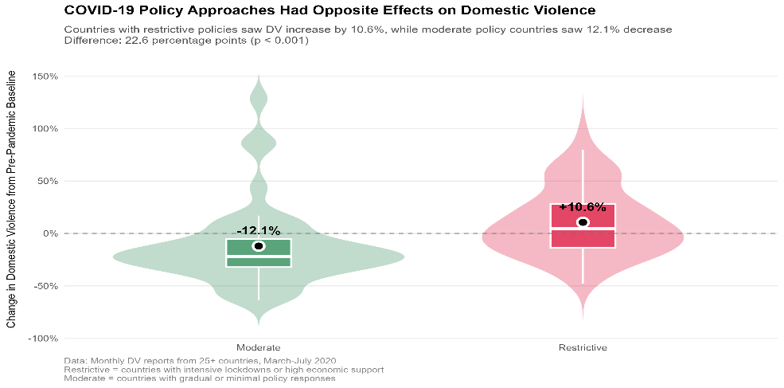Stage 1 – Policy approach and lockdowns Thresholdsds:

Countries with restrictive COVID-19 policies (intensive lockdowns or substantial economic support) experienced a 10.6% increase in domestic violence, while those with moderate approaches saw a 12.1% decrease—a statistically significant 22.6 percentage point difference.

Figure 1

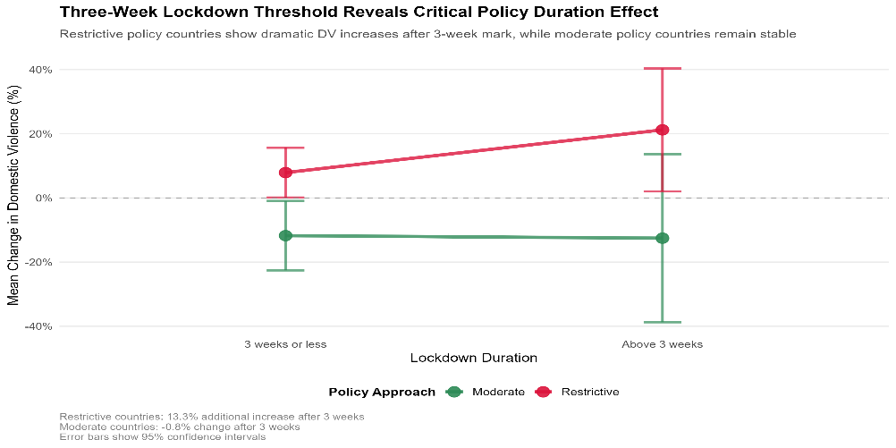The critical mechanism is lockdown duration: restrictive countries with lockdowns ≤3 weeks showed modest increases (+9%), but those extending beyond three weeks experienced dramatic escalation to +21.2%. The three-week threshold provides actionable guidance for policymakers, as moderate policy countries maintained stable rates regardless of duration.

Figure 2

Stage 2 - Aftereffects of Lockdowns on Domestic Violence: We analyzed 11 country-level lockdown waves with full data for both lockdown and 1–4 months after. For each, we compared average DV rates post-lockdown to during, producing an “aftereffect” score. Both scatter and boxplots revealed a clear upward trend, with lockdowns longer than ~54 days consistently followed by higher DV levels. This aligns with studies showing delayed DV surges post-confinement (e.g., Anderberg et al., 2020). While our sample is small, this pattern supports the 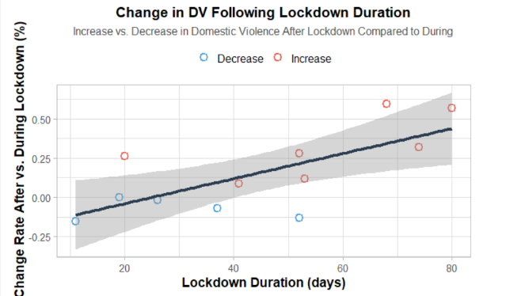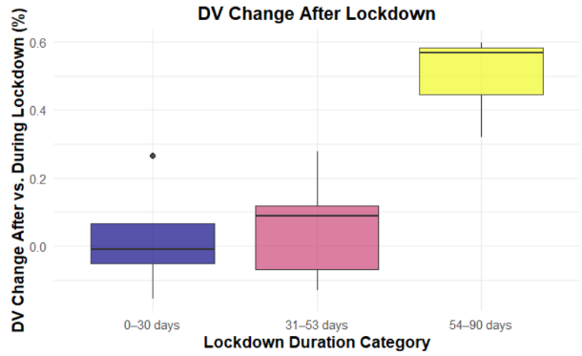idea that prolonged lockdowns may lead to cumulative social strain.

Figure 3

Figure 4

Stage 3 – Estimating optimal Lockdown length:

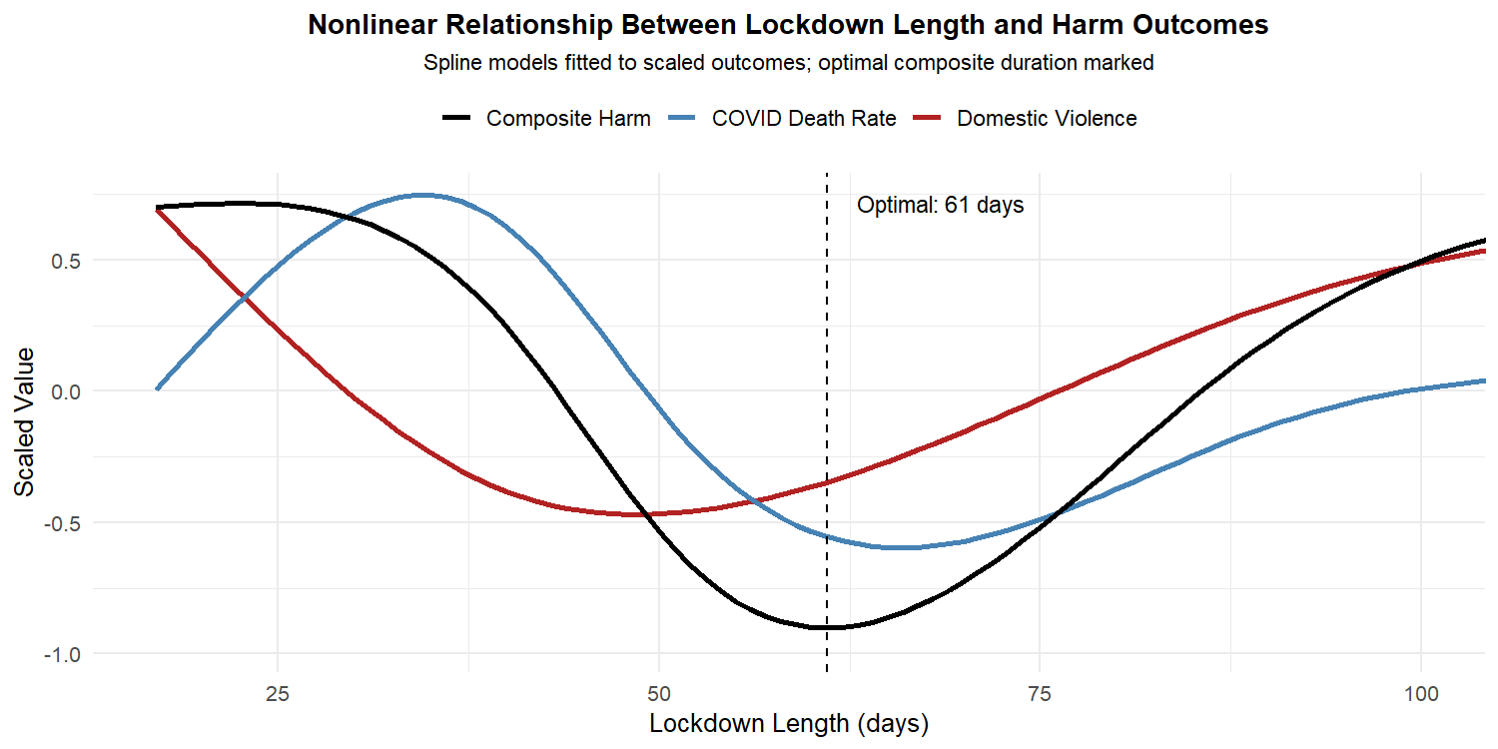We created a composite harm score combining scaled DV percent change and scaled COVID death percent change from the previous month. Using 35 post-April country-months, we modeled this outcome against lockdown length via a spline regression (df = 4). The model explained 27% of the variance (**Adjusted R² = 0.27**) and was statistically significant (**F(4,30) = 3.29, p = 0.024**), showing a U-shaped curve with a minimum at **61 days**—suggesting that extending lockdowns beyond two months may worsen combined health and social harms. A comparison model using death change from baseline yielded a similar curve (optimal day = 55) but weaker fit (Adj. R² = 0.13, p = 0.06). While exploratory, the result aligns with prior findings that long lockdowns can become counterproductive (Anderberg et al., 2020).

Figure 5

Top of Form

Bottom of Form

**4. Future work & Limitations:**

Our analysis is based on a small sample of countries with incomplete and uneven reporting. In many cases, domestic violence was likely underreported, especially during lockdowns, and some lockdowns continued beyond our dataset, limiting post-lockdown insights.

We used simplified indicators (death and DV rates per million) and focused only on reported cases. This may underestimate real harm, as shown in prior work using search data and helpline calls (e.g., Anderberg et al., 2020).

Future research could expand the dataset, include more countries and months, and integrate additional sources like Google Trends or survey data. With larger samples, stronger statistical models or causal frameworks could be applied to test these patterns more rigorously.Our findings are exploratory—but they align with past studies and show how even small datasets can support informed thinking about policy trade-offs.

**Appendix:**

[Estimating the effects of non-pharmaceutical interventions on COVID-19 in Europe (Flaxman, Mishra, Gandy...)](https://www.nature.com/articles/s41586-020-2405-7)

[Quantifying Domestic Violence in Times of Crisis (Anderberg)](https://d.docs.live.net/23be1045bd672b89/מסמכים/BGU/4th_semester/data_analysis/research/useful%20files/Quantifying-Domestic-Violence-in-Times-of-Crisis.pdf)

[Domestic violence during the COVID-19 pandemic - Evidence from a systematic review and meta-analysis (Piquero, Jennings ...)](https://research.monash.edu/en/publications/domestic-violence-during-the-covid-19-pandemic-evidence-from-a-sy)

[Sheltering in place and domestic violence: Evidence from calls for service during COVID-19 (Leslie, Wilson)](https://pubmed.ncbi.nlm.nih.gov/32834179/)

[A Pandemic within a Pandemic — Intimate Partner Violence during Covid-19 (Evans, Lindauer...)](https://www.nejm.org/doi/full/10.1056/NEJMp2024046)

[Link to Data Drive](https://drive.google.com/drive/folders/16yZ8y3rKgJtmsxSOGfqoK7k46Sm0efNz?usp=sharing)